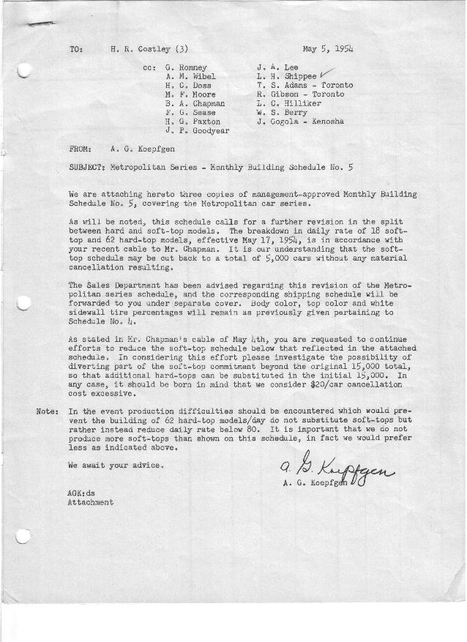

FORM PLAN 68 REV. 9-40-N.K.P PRINTED IN U.S.A

SCHEDULE NO. ______5_________ DATE May 5, 1954 MONTHLY BUILDING SCHEDULE APPROVED_____F. G. Sease (signed) ________DATE__ 5-6-54 ___ REVISION NO. ________________ DATE ________________ PRODUCT APPROVED_____B. A. Chapman (signed) ___________DATE_ _5-6-54____ ___
Metropolitan Series – Austin Motors Co., Ltd., - England
DESCRIPTION | BUILT  ACT◻ EST  THRU  4-30-54 | FIRM BUILDING SCHEDULE (a)  (FABRICATED MATERIAL RELEASE) |  |  |  |  |  |  |  |  |  |  |  |  |  |  |  |  |  | GRAND  TOTAL
DESCRIPTION | BUILT  ACT◻ EST  THRU  4-30-54 | MONTH May  DAYS 21 |  |  | MONTH June  DAYS 19 |  |  | MONTH July  DAYS 17 (b) |  |  | MONTH August  DAYS 16 (b) |  |  | MONTH September  DAYS 22 |  |  | MONTH October  DAYS 22 |  |  | GRAND  TOTAL
DESCRIPTION | BUILT  ACT◻ EST  THRU  4-30-54 | DAILY | MONTH | CUM’L  TOTAL | DAILY | MONTH | CUM’L  TOTAL | DAILY | MONTH | CUM’L  TOTAL | DAILY | MONTH | CUM’L  TOTAL | DAILY | MONTH | CUM’L  TOTAL | MONTH | MONTH | MONTH | GRAND  TOTAL
Hard-Top Convertible | 2466 | 57-10da  62-11da | 1252 | 3718 | 62 | 1178 | 4896 | 62 | 1054 | 5950 | 62 | 992 | 6942 | 62 | 1364 | 8306 | 62 | 1364 | 9670
Soft-Top Convertible | 2797 | 19-10da  18-11da | 387 | 3184 | 18 | 342 | 3526 | 18 | 306 | 3832 | 18 | 288 | 4120 | 18 | 396 | 4516 | 18 | 396 | 4912
Total | 5263 | 76-10da  80-11da | 1639 | 6902 | 80 | 1520 | 8422 | 80 | 1360 | 9782 | 80 | 1280 | 11062 | 80 | 1760 | 12822 | 80 | 1760 | 14582
Over/(Under) Sched. #4 | (36) |  | (41) | (77) |  | 0 | (77) |  | 0 | (77) |  | 0 | (77) |  | 0 | (77) |  | 0 | (77)
MONTH November
DAYS 5
Hard-Top Convertible |  | 62 | 330 | 10000
Soft-Top Convertible |  | 18 | 88 | 5000
Total |  | 80 | 416 | 15000
Over/(Under) Sched. #4 |  |  | 77 | 0
NOTES
- Firm Schedule through 15,000 jobs
- Vacation period – July 26 – August 6 inclusive

